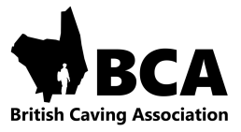

British Caving Association
Cave and Mine Leader Award Logbook

How to use the logbook

Use one line for each trip.

Once you have completed your Cave or Mine Leader award it is acceptable to block record regular trips e.g. 20 trips to Long Churn with primary school children in a variety of water levels.

Date: Date of the trip

Trip Details: Record any particulars of the trip including route within a system e.g. round trip or through trip, techniques used e.g. ladder and line, SRT, Tyrolean, pull through, bolting, surveying, photography, digging, water levels, weather and ground conditions or party size as appropriate.

Role: Show whether it was a trip with peers, an assistant or leading the party.

Time: Record the time, to the nearest hour, spent underground. This shows whether you are doing some good long trips which may qualify as a “Quality Trip” and also helps with calculating your Radon exposure.

Quality Trip: Please go to the website for the definition of a quality trip

