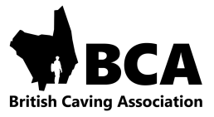

British Caving Association
Cave and Mine Leader Award Logbook

This logbook belongs to ______________________________

Date of Birth _______________________________________

Award scheme membership number ME ________________

This logbook can be used to record all your cave and mine experience details as you progress through the BCA award schemes.

It should be used in conjunction with our online system at
www.britishcaving.azolve.com. Here you have an account and can manage personal details, book courses and see your credentials and qualifications. When you gain a certificate it will be generated via the online system but you can down load and print a copy to hold in this log book if you wish.

Enquiries can also be made via the online system.

Further information can also be found on the n the BCA website

www. british-caving.org.uk


P.T.O

