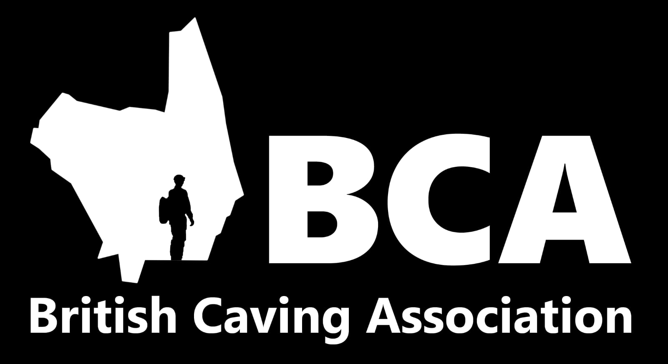

BCA Youth and Development Kit Loan Scheme
Proposed by the CHECC Representative (David Botcherby)
Agreed by BCA Secretary in 2018 (exact date unknown)

A constant problem and source of worry for many university clubs is kit. Caving requires a lot of expensive kit to do, which needs replacing every few years. As a result, many clubs are out of pocket for new kit, which can end up limiting the club in terms of how many new cavers they can support.

My proposal is this: use the cash reserve of the BCA to give long-term loans to university clubs to buy new kit. This would be paid back over a three-year period using a bespoke payment plan agreed with applicant clubs on receipt of the loan.

This kit loan will use the existing structure of the loan for new clubs but will likely consist of multiple smaller loans for different clubs rather than larger one-off loans for an entire club’s worth of kit. This means that the overall load on the BCA in terms of money lent out is likely to be smaller. The loans going to existing clubs will mean that the money is more likely to return, as the clubs are less likely to fold.

The loan would work via an application to CHECC, which would then be brought before the BCA for approval by two council members, one of which being the Treasurer. The initial stage running through CHECC will be beneficial, as it will allow some negotiation and advice to be given before the revised application is presented to the BCA, as well as reducing the overall workload on the BCA. Any new loans will be included in the Treasurer’s report to Council. Applications will consist of a properly costed list of kit, including the specific kit to be bought, as well as where it will be sourced from. The BCA will then purchase this kit for the club, and CHECC will arrange transport to the club if necessary. This allows the kit to default to the BCA in scenarios such as the club folding, detailed below.

Payment plans are best agreed on a case-by-case basis with individual clubs. University funding for clubs is variable in its amount and regularity, so it is difficult to make a ‘one size fits all’ type plan. An example club would be SUSS (Sheffield University Speleological Society), who can receive a safety budget of around £100 every half year. This could pay off a loan of £400 in two years.

The payment plan should be set up so as to draw from university funding opportunities, rather than passing the debt onto the individual cavers. CHECC will provide advice on budgeting and funding to enable the club to repay the debt.

The maximum individual loan will be £500. If a club reaches the end of the three years without paying off their debt, and cannot pay the balance, CHECC will pay the balance. Similarly, if a club cannot make payments, CHECC will buy the kit off the BCA, taking on the debt and enabling the club to continue using it. In this way, CHECC can act as a guarantor for student clubs, minimising the risk of the BCA losing money to defaulters.

The maximum total value the BCA can have out in these loans is £5000.

This is likely to generate a lot of goodwill for the BCA from among student clubs, as well as the wider caving world as we are supporting the next generation of cavers. Loan recipients will be encouraged to post on social media etc to publicise how the BCA has helped them to continue caving.

